Reset Student Password or Forgotten Password
- Go to password.mustangps.org
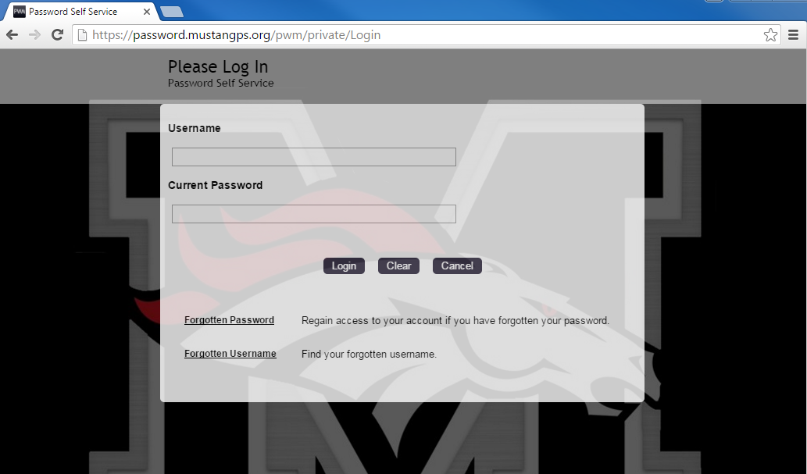
- Click Forgotten Password
- Enter username (student#lastname)
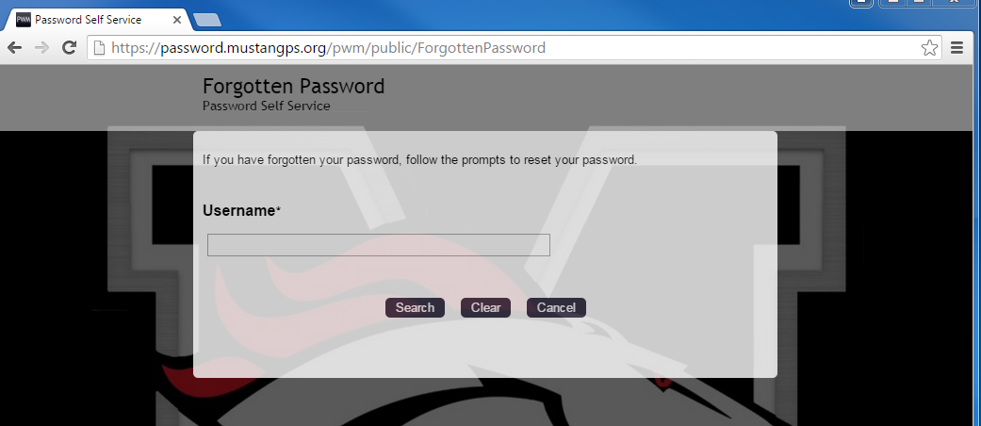
Enter student#lastname
- Type in first name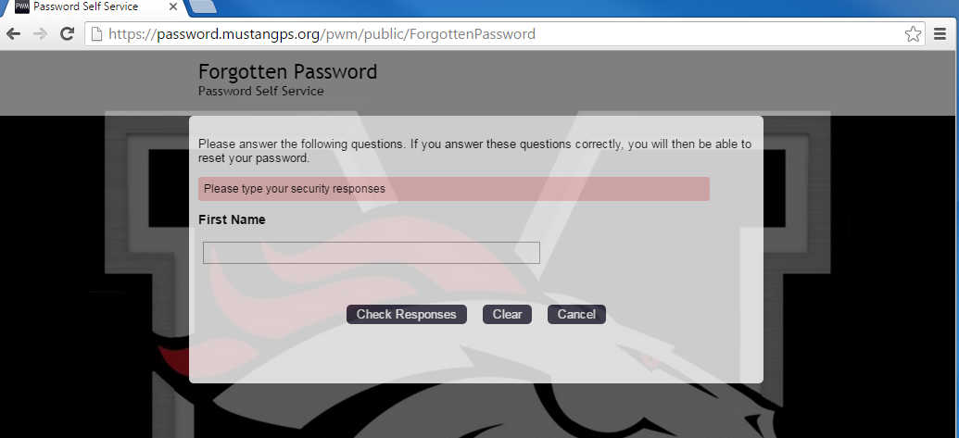
- Type in the new password. Passwords are case sensitive, must be at least 8 characters long, cannot be part of your username, and must 3 of the following: Uppercase (A-Z), lowercase (a-z), Number (0-9), or symbol (!#$, etc.).
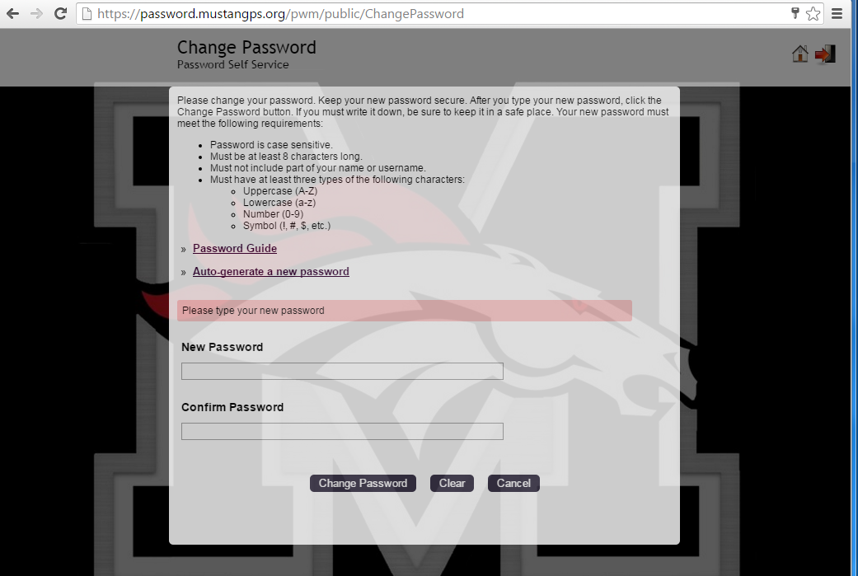
- Retype password

